AZ Sestante Limited

Managed Account Statement of Advice (SOA) Guidance Wording For CFS FirstChoice Managed Accounts Index Portfolios

March 2023

Important information
This document has been prepared by AZ Sestante Limited ABN 94 106 888 662 AFSL 284 442 (‘AZ Sestante’). Adviser use only as a guidance wording for the use of Statement of Advice (SOA’s). This document is not an offer of securities or financial products, nor is it financial product advice. As this document has been prepared without taking account of any investors’ particular objectives, financial situation or needs, you should consider its appropriateness having regard to your objectives, financial situation and needs before taking any action. Past performance is not a reliable indicator of future results. Although specific information has been prepared from sources believed to be reliable, we offer no guarantees as to its accuracy or completeness. The information stated, opinions expressed, and estimates given constitute best judgement at the time of publication and are subject to change without notice. Consequently, although this document is provided in good faith, it is not intended to create any legal liability on the part of any other entity and does not vary the terms of a relevant disclosure statement. All dollars are Australian dollars unless otherwise specified.

About Us
AZ Sestante Limited (AZ Sestante) is the AFS-licensed, wholly owned Australian subsidiary of AZ International, part of Azimut Holding S.p.A (Azimut), Italy’s leading independent asset manager.
Established in 2016, we specialise in designing and administering a focused range of multi-manager investment solutions and managed accounts for our clients. Our parent company Azimut, Italy’s largest independent asset manager, was established in 1989 and listed on the Italian stock exchange in 2004.
Our investment solutions are designed to cater to our clients’ specific risk and return objectives through our suite of flagship multi-manager capabilities. Underpinning our product design is the global multi-manager investment resources of Azimut. Azimut’s multi-manager approach is characterised by actively managed, outcome-oriented portfolios, leveraging best-in-class, specialist investment managers within a cost-efficient framework. Azimut’s global multi-manager team (the Investment Manager) and AZ Sestante’s Investment Committee (the Investment Committee) work closely with the Responsible Entity of the offers, to ensure appropriate levels of independent governance and oversight as well as ongoing risk management and compliance. Our goal is to consistently deliver favourable and cost-efficient investment outcomes for our clients within a well-defined risk management and governance framework.
What We Offer
Our suite of CFS FirstChoice managed accounts are designed to cover a wide range of client risk and return objectives. Our Index portfolios combine dynamic asset allocation with passive investment managers to provide efficient and cost effective portfolios.
The following table highlights our current offerings:
Multi-manager Solution | Asset Allocation | RBA Cash Rate Outperformance Target p.a. after fees
 |  | Dynamic
CFS AZ Sestante Index Conservative | 30% Growth  70% Conservative | + 1.5%
CFS AZ Sestante Index Moderate | 40% Growth  60% Conservative | + 2%
CFS AZ Sestante Index Diversified | 50% Growth  50% Conservative | +2.5%
CFS AZ Sestante Index Balanced | 70% Growth  30% Conservative | + 3.25%
CFS AZ Sestante Index Assertive | 85% Growth  15% Conservative | + 4%
CFS AZ Sestante Index Aggressive | 97.5% Growth  2.5% Conservative | +4.5%

Our Distinguishing Characteristics

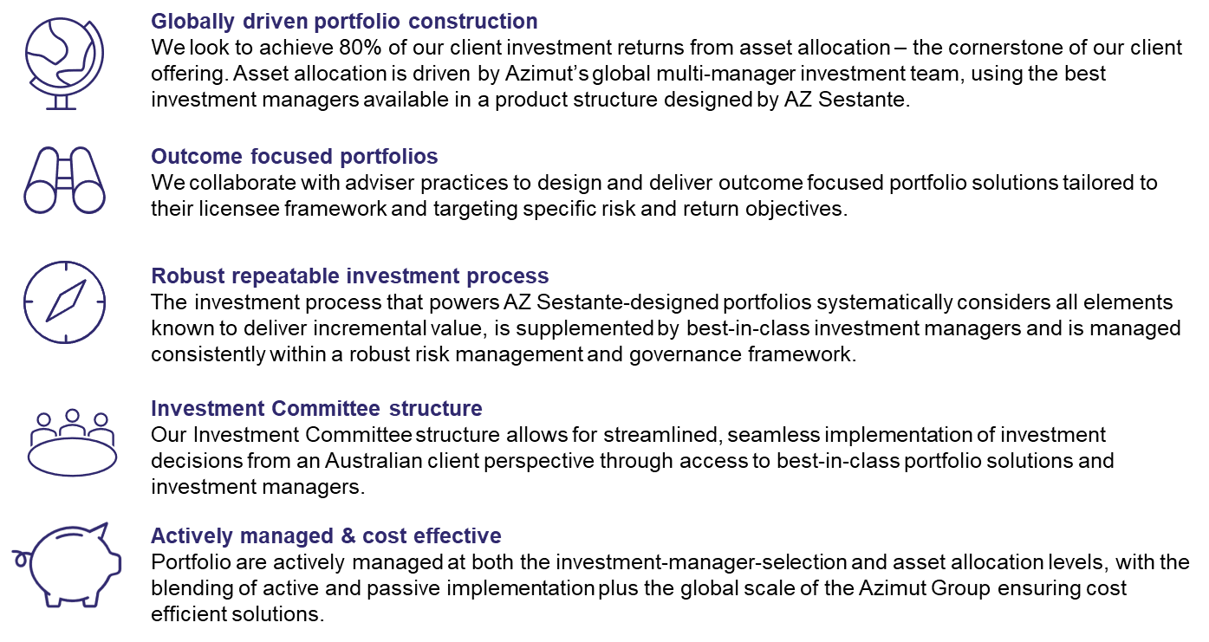

Investment Philosophy

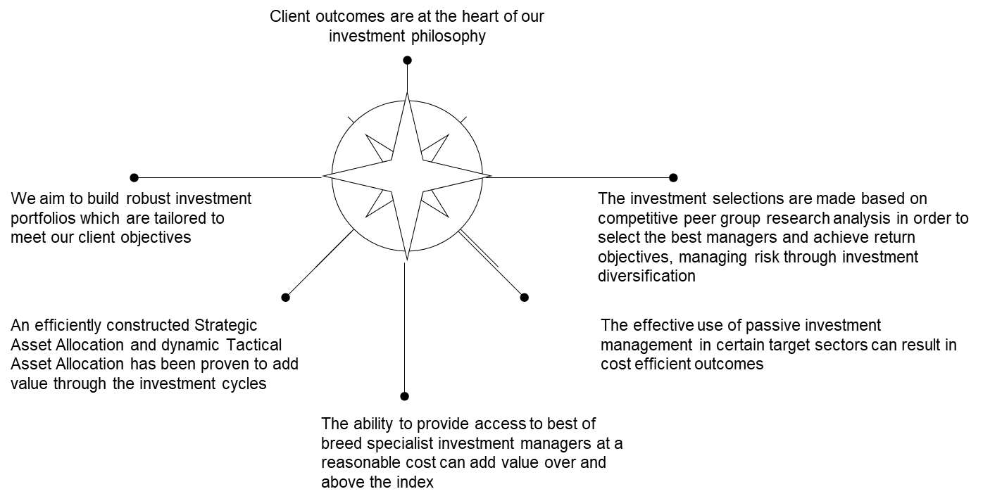

5 Key Pillars of our Approach
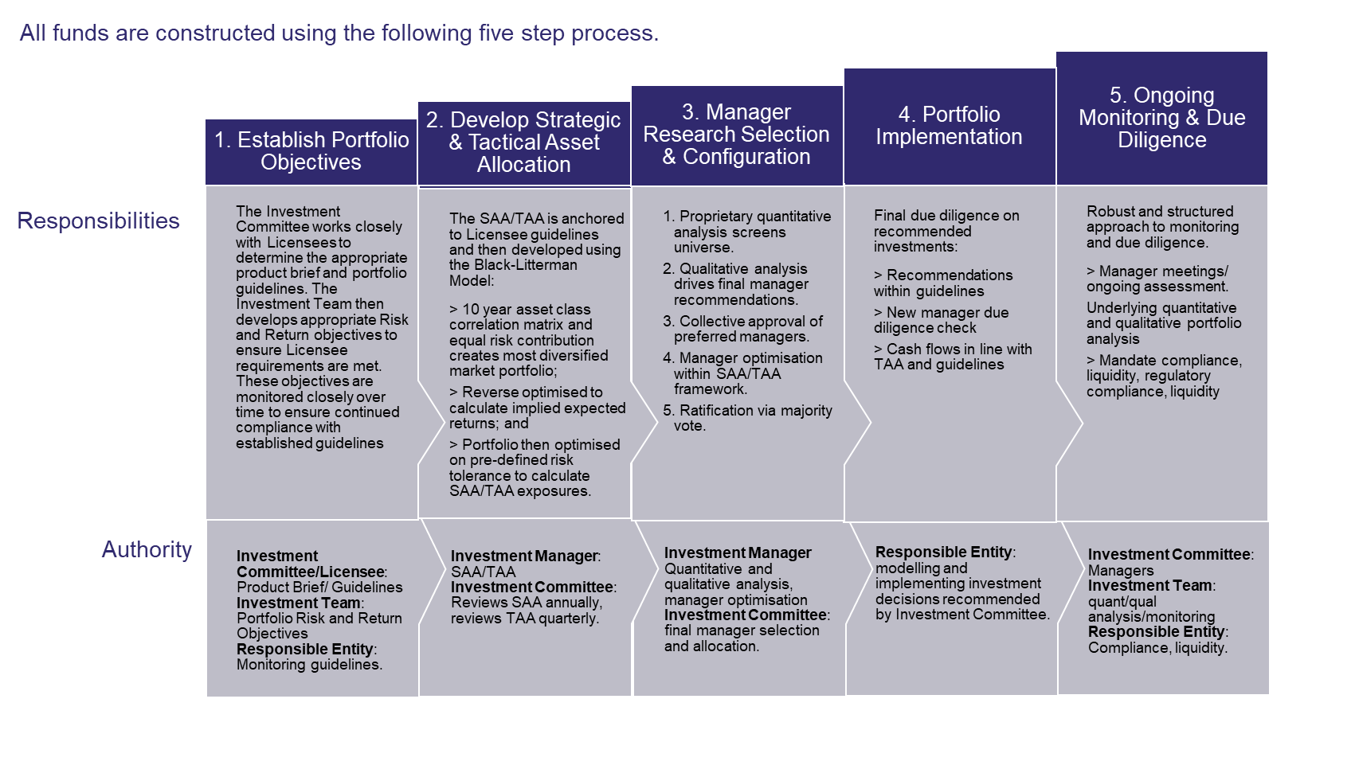

Investment Team Supported by Global Breadth & Depth of the AZ Global Investment Platform

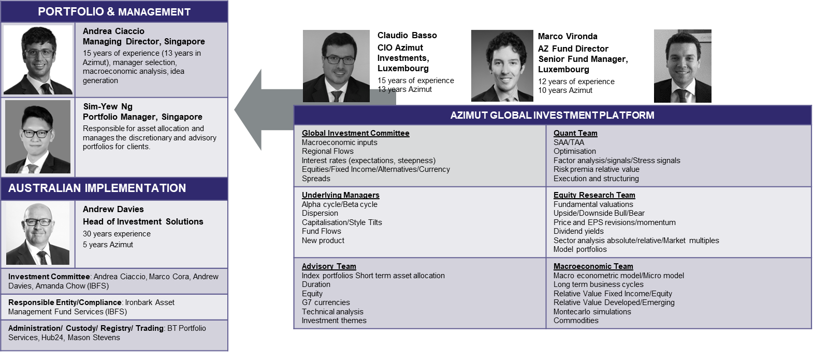
Appendix – Managed Account Inserts & “Why Managed Account” Language

AZ Sestante offers six Index managed portfolios on CFS FirstChoice. Based on your “[insert]” risk profile, we have recommended that you invest in the ‘AZ Sestante Index “[insert]” Portfolio through the CFS FirstChoice platform. Information on the recommended managed portfolio is provided below.

CFS AZ Sestante Index Conservative Portfolio

Objective | To deliver outperformance of the RBA cash rate +1.5% p.a. (after fees) over a rolling 3-year period.
Suitable for | Designed for investors who seek stable, regular income from low volatility assets but with some exposure to the share market and are focussed on capital preservation and are prepared to forego the potential of higher returns for lower volatility and the preservation of capital.
Investment style and  approach | Active - The portfolio aims to utilise AZ Sestante’s portfolio construction capabilities and invest in high quality asset investments with 70% exposure to defensive assets (such as cash and fixed interest) and 30% exposure to growth assets (such as shares, property, infrastructure, and alternative assets). This approach aims to provide enhanced diversification and improve risk adjusted returns.
Suggested min timeframe | A minimum investment horizon of 3 years.
Standard risk measure | 4 - Medium risk of short-term loss
Asset Allocation | Minimum | Maximum
Australian shares  Australian small caps | 5  0 | 20  10
International Shares  Emerging Markets  Specialist International | 5  0  0 | 20  5  5
Alternatives | 0 | 10
Diversified Real Return | 0 | 10
Listed Property + infrastructure | 0 | 15
Fixed Interest + cash  Cash | 60  20 | 80  50
Defensive  Growth | 60  20 | 80  40

CFS AZ Sestante Index Moderate Portfolio

Objective | To deliver outperformance of the RBA cash rate +2% p.a. (after fees) over a rolling 4-year period.
Suitable for | Designed for investors who seek relatively stable, regular income from low volatility assets but with some exposure to the share market and are focussed on capital preservation and are prepared to forego the potential of higher returns for lower volatility and the preservation of capital.
Investment style and  approach | Active - The portfolio aims to utilise AZ Sestante’s portfolio construction capabilities and invest in high quality asset investments with 60% exposure to defensive assets (such as cash and fixed interest) and 40% exposure to growth assets (such as shares, property, infrastructure, and alternative assets). This approach aims to provide enhanced diversification and improve risk adjusted returns.
Suggested min timeframe | A minimum investment horizon of 4-years.
Standard risk measure | 5 - Medium risk of short-term loss
Asset Allocation | Minimum | Maximum
Australian shares  Australian small caps | 10  0 | 25  10
International Shares  Emerging Markets  Specialist International | 10  0  0 | 25  5  5
Alternatives | 0 | 15
Diversified Real Return | 0 | 10
Listed Property + infrastructure | 0 | 20
Fixed Interest + cash  Cash | 40  10 | 60  30
Defensive  Growth | 40  40 | 60  60
CFS AZ Sestante Index Diversified Portfolio

Objective | To deliver outperformance of the RBA cash rate +2.5% p.a. (after fees) over a rolling 5year period.
Suitable for | Designed for investors who seek relatively stable, regular income from low volatility assets but with some exposure to the share market and are focussed on capital preservation and are prepared to forego the potential of higher returns for lower volatility and the preservation of capital.
Investment style and  approach | Active - The portfolio aims to utilise AZ Sestante’s portfolio construction capabilities and invest in high quality asset investments with 50% exposure to defensive assets (such as cash and fixed interest) and 50% exposure to growth assets (such as shares, property, infrastructure, and alternative assets). This approach aims to provide enhanced diversification and improve risk adjusted returns.
Suggested min timeframe | A minimum investment horizon of 5-years.
Standard risk measure | 5 - Medium risk of short-term loss
Asset Allocation | Minimum | Maximum
Australian shares  Australian small caps | 10  0 | 25  10
International Shares  Emerging Markets  Specialist International | 10  0  0 | 25  5  5
Alternatives | 0 | 15
Diversified Real Return | 0 | 10
Listed Property + infrastructure | 0 | 20
Fixed Interest + cash  Cash | 40  10 | 60  30
Defensive  Growth | 40  40 | 60  60

CFS AZ Sestante Index Balanced Portfolio

Objective | To deliver outperformance of the RBA cash rate +3.25% p.a. (after fees) over a rolling 6year period.
Suitable for | Designed for investors who seek a diversified portfolio with exposure to growth and defensive assets, seeking moderate growth over the investment timeframe with a moderate level of income, and accept a moderate degree of volatility with a relatively higher exposure to growth assets.
Investment style and  approach | Active - The portfolio aims to utilise AZ Sestante’s portfolio construction capabilities and invest in high quality asset investments with 30% exposure to defensive assets (such as cash and fixed interest) and 70% exposure to growth assets (such as shares, property, infrastructure, and alternative assets). This approach aims to provide enhanced diversification and improve risk adjusted returns.
Suggested min timeframe | A minimum investment horizon of 6-years.
Standard risk measure | 6 - High risk of short-term loss
Asset Allocation | Minimum | Maximum
Australian shares  Australian small caps | 15  0 | 30  10
International Shares  Emerging Markets  Specialist International | 15  0  0 | 30  5  5
Alternatives | 0 | 15
Diversified Real Return | 0 | 15
Listed Property + infrastructure | 0 | 20
Fixed Interest + cash  Cash | 30  10 | 50  30
Defensive  Growth | 30  50 | 50  70

CFS AZ Sestante Index Assertive Portfolio

Objective | To deliver outperformance of the RBA cash rate +4% p.a. (after fees) over a rolling 7year period.
Suitable for | Designed for investors who seek a relatively high level of capital growth on their investment, a modest level of income, and are willing to accept a high level of short to medium term capital volatility.
Investment style and  approach | Active - The portfolio aims to utilise AZ Sestante’s portfolio construction capabilities and invest in high quality asset investments with 15% exposure to defensive assets (such as cash and fixed interest) and 85% exposure to growth assets (such as shares, property, infrastructure and alternative assets). This approach aims to provide enhanced diversification and improve risk adjusted returns.
Suggested min timeframe | A minimum investment horizon of 7 years.
Standard risk measure | 6 - Medium risk of short-term loss
Asset Allocation | Minimum | Maximum
Australian shares  Australian small caps | 15  0 | 40  15
International Shares  Emerging Markets  Specialist International | 15  0  0 | 40  10  10
Alternatives | 0 | 20
Diversified Real Return | 0 | 15
Listed Property + infrastructure | 0 | 20
Fixed Interest + cash  Cash | 20  0 | 40  10
Defensive  Growth | 20  60 | 40  80

CFS AZ Sestante Index Aggressive Portfolio

Objective | To deliver outperformance of the RBA cash rate +4.5% p.a. (after fees) over a rolling 7-year period.
Suitable for | Designed for investors who seek a relatively high level of capital growth on their investment, a modest level of income, and are willing to accept a high level of short to medium term capital volatility.
Investment style and  approach | Active - The portfolio aims to utilise AZ Sestante’s portfolio construction capabilities and invest in high quality asset investments with 2.5% exposure to defensive assets (such as cash and fixed interest) and 97.5% exposure to growth assets (such as shares, property, infrastructure, and alternative assets). This approach aims to provide enhanced diversification and improve risk adjusted returns.
Suggested min timeframe | A minimum investment horizon of 7 years.
Standard risk measure | 7 - High risk of short-term loss
Asset Allocation | Minimum | Maximum
Australian shares  Australian small caps | 25  0 | 50  20
International Shares  Emerging Markets  Specialist International | 25  0  0 | 60  15  15
Alternatives | 0 | 20
Diversified Real Return | 0 | 15
Listed Property + infrastructure | 0 | 20
Fixed Interest + cash  Cash | 0  0 | 20  10
Defensive  Growth | 0  80 | 20  100

Why Managed Accounts?
Investing via a Managed Account
Managed Accounts provide investors with exposure to professionally managed portfolios where the beneficial ownership of the underlying investments within the account rests with the investor. This is one of the key attractions of the Managed Account structure.
Reasons
- A Managed Account is appropriate for you as it allows us to efficiently implement our recommended “dynamic asset allocation” strategy – a strategy designed to achieve solid returns with less volatility irrespective of market or benchmark allocations.
- A Managed Account provides access to professionally run investment portfolios managed by a professional investment manager – AZ Sestante, also known as the “Model Manager”. AZ Sestante will continually review the assets held in your Model and, if the actual holdings in your managed account do not align with the reference allocation for your account, your portfolio will be rebalanced. The asset allocation will ‘float’ based on daily market valuations and be rebalanced where AZ Sestante feels adjustments are required in response to investment markets or the economic outlook.
There are some key advantages that a “Managed Account” offers over a more traditional “Managed Fund “structure of investing:
- Greater Control: There are a variety of underlying Managed Portfolios available giving you the opportunity to select a particular investment strategy that is appropriate for your needs.
- Greater transparency: The underlying assets of the Managed Account you choose are held in your account. You can see exactly where your money is invested, how each asset contributes to your investment performance, and what investment decisions have been implemented on your behalf. This is different from a managed fund where visibility over the underlying assets is more obscured.
- Cost effectiveness: If you decide to change between Managed Portfolios, only those assets that are different or have different weightings between the two models will need to be traded. This can reduce transaction costs and tax when you switch between models.
- Tax effectiveness: Since there is no embedded tax liability within a Managed Account structure, the investor does not face any tax consequences as other investors enter or exit the Managed Account. This is not the case with a traditional managed fund investment where, at times, you can have significant unrealised capital gains embedded in the unit price of the fund - which a new investor then inherits, even though they didn’t participate in those gains. In the case of a Managed Account investor, for better or worse, your capital gains tax liability is your own and the tax impact is not affected by other investors. The tax you pay on the investments will be a direct result of the income and capital gains from your investments only.
- Flexibility: You retain the beneficial ownership of the underlying assets – which is different from investing via a traditional managed fund. With a Managed Account, you hold the underlying assets in your account, rather than as units in a managed fund. This provides greater flexibility and control over your investments. It also provides the ability to customise your portfolio to meet your individual preferences than a traditional managed fund.
Implications
- A Managed Account investment is an investment portfolio which is actively managed by investment professionals. There is an “Investment Management Fee” which is charged by CFS FirstChoice and AZ Sestante (the administrator of the product) for the work they do in managing your investment.
- The investments in a Managed Account are based on the decisions of the Model Manager. Investment management decisions can be subjective and while Model Managers are required to exercise reasonable care and diligence, there is a risk that their investment decisions will result in the model not achieving its objectives.
- “Model mismatching”: the actual asset holdings in your underlying portfolio are unlikely to perfectly match the holdings of your chosen model. This can be caused by the implementation of minimum holding sizes, and differences in timing and prices achieved for trades. As a result, the actual investment performance of your Managed Account may differ from the reported outcomes of the models.
- Transaction costs: the amount of trading associated with portfolio rebalances will impact your transaction costs and investment performance. Trading may be caused by investment decisions of your Model Manager as well as by changes you make to your Managed Account such as additions and withdrawals. The application of minimum trade sizes, minimum holding sizes and your investment preferences may also cause more frequent trading to occur as part of the rebalance, particularly on smaller account balances.
For a complete explanation of the risks associated with Managed Accounts, please refer to the CFS Firstchoice Product Disclosure Statement (PDS).

